**Chapter 1**

# Introduction

The Digital Library System (DLS) is a modern and innovative solution that aims to transform the way users interact with libraries and access digital resources. Unlike traditional libraries, which rely on physical collections and manual processes, the DLS harnesses the power of technology to streamline library operations and provide a seamless digital experience to users.

At its core, the DLS focuses on two primary aspects: efficient resource management and enhanced user experience. By digitizing library collections and automating key processes, the system simplifies the tasks of librarians and empowers users to explore, borrow, and interact with digital resources in a convenient and intuitive manner.

The DLS employs a robust infrastructure and advanced algorithms to organize and categorize digital resources, such as e-books, research papers, articles, and multimedia content. Librarians can easily upload and catalog these resources, assigning appropriate metadata and tags to ensure accurate indexing and searchability. This systematic organization enables users to quickly locate relevant resources based on various criteria, such as title, author, subject, or keywords.

## Objective and Scope of the Project

The objective of the Digital Library System (DLS) project is to develop a comprehensive and user-friendly web-based platform that simplifies the management of digital resources in a library setting. The project aims to achieve the following goals:

**Automation of Library Management:** The DLS aims to automate various tasks performed by a library manager, such as book cataloging, record-keeping, and due date management. By implementing an efficient system, the project simplifies the administrative work involved in managing a library.

**User Registration and Authentication:** The project enables users to register and create personal accounts. Upon registration, users can log in to the system using their credentials, which allows them to access their borrowing history and due dates.

**Borrowing Management:** The DLS provides functionalities for users to borrow books from the library. Users can search for available books, select the ones they want to borrow, and complete the borrowing process online. The system keeps track of borrowed books and due dates.

**Due Date Notifications:** The project includes a notification system that sends reminders to users about upcoming due dates. Users will receive timely notifications informing them of the books they need to return, helping them avoid late returns and associated penalties.

**Scope:**

**User Registration and Login:** Implement a user registration and login system for users to create accounts and securely access their information.

**Book Cataloging and Management:** Develop a system for library managers to add and update book records, including details such as title, author, genre, and availability status.

## Literature Survey

**Identify Existing Solutions:** Explore and examine existing library management systems and digital library platforms to understand their features, functionalities, and technologies employed. This helps in identifying best practices and potential areas for improvement in the DLS project.

**Understand User Requirements:** Analyze literature to identify common user requirements and expectations from a library management system. This provides insights into user needs, preferences, and challenges faced in existing systems, which can be incorporated into the design and development of the DLS.

**Explore Technical Considerations:** Investigate the technical aspects of library management systems, including database design, user interfaces, security measures, and integration with external systems. This helps in selecting appropriate technologies and frameworks for the development of the DLS.

**Review Research and Innovations:** Examine research papers, academic articles, and publications related to library management and digital libraries. This allows for the exploration of emerging trends, innovative approaches, and potential areas of improvement that can be incorporated into the DLS project.

**Analyze Success Stories and Case Studies:** Study successful implementations of library management systems and digital libraries in real-world scenarios. This helps in understanding the challenges faced during implementation, lessons learned, and strategies for effective system deployment and user adoption.

**Chapter 2**

# System Analysis

## 2.1 Problem Definition

The problem that the Digital Library System (DLS) project aims to address is the inefficiency and lack of transparency in traditional library management systems. Traditional library systems often involve manual processes, limited access to information, and difficulty in tracking borrowed books and due dates. These challenges can lead to user dissatisfaction, delayed returns, and increased administrative burden.

Users often face difficulties in accessing information about their borrowed books, due dates, and availability. The project intends to provide users with a user-friendly interface where they can easily view their borrowed books, due dates, and receive notifications for upcoming returns.

Library administrators often lack comprehensive tools for managing book inventory, generating reports, and monitoring user activity. The project aims to provide administrators with a dashboard or administrative interface to track book availability, generate reports, and manage user accounts efficiently.

## 2.1 Existing System

The existing system refers to the current state of library management processes and technologies that are in place before the implementation of the Digital Library System (DLS) project. The existing system may vary depending on the specific library or institution being considered. However, common characteristics of traditional library management systems include:

**Manual Book Cataloging**: Books are manually cataloged and organized using physical methods such as card catalogs or manual entry into a database. This process can be time-consuming and prone to human errors.

**Manual Borrowing and Return Process:** Users typically interact with library staff to borrow and return books. Transactions are recorded manually, and due dates may be tracked using manual methods such as due date stamps on physical books or paper-based borrowing records.

**Limited Accessibility:** Users may have limited access to their borrowing history, due dates, and availability of books. They often need to visit the library in person to inquire about their borrowing status or check book availability.

**Lack of Advanced Search Capabilities:** The search functionality in traditional library systems may be limited to basic parameters such as book titles or author names. Advanced search features, such as filtering by genre, keyword search, or sorting options, may be absent or limited.

**Manual Record-Keeping:** Library staff maintains manual records of book inventory, user borrowing records, and overdue fines. This process can be labor-intensive and susceptible to errors or inconsistencies.

**Limited Reporting and Analytics:** Generating reports or obtaining insights from library data may require manual compilation and analysis of information. This can be time-consuming and may not provide comprehensive data analysis or visualization capabilities.

## 2.4 Proposed System

The proposed system, the Digital Library System (DLS), aims to revolutionize library management by introducing a comprehensive and user-friendly digital solution. The key features and improvements of the proposed system include:

**Online Book Catalog:** The DLS will provide an online catalog of books, allowing users to browse and search for books based on various criteria such as title, author, genre, and keywords. This digital catalog will offer a more efficient and convenient way for users to discover and explore the library's collection.

**User Accounts and Borrowing Management:** Users will have personalized accounts where they can view their borrowing history, due dates, and receive notifications for upcoming returns. The DLS will automate the borrowing and return process, allowing users to manage their borrowing activities online without the need for manual interactions with library staff.

**Advanced Search Functionality:** The proposed system will include advanced search capabilities, enabling users to perform complex searches and refine their results based on specific criteria. This will make it easier for users to find relevant books and enhance their overall search experience.

**Automated Record-Keeping**: The DLS will automate the record-keeping process, eliminating the need for manual paper-based records. Information such as book inventory, borrowing records, and fines will be stored and managed digitally, ensuring accuracy and ease of access for both users and administrators.

**Administrative Tools and Reports:** The proposed system will provide administrators with a dedicated dashboard or administrative interface. This interface will enable administrators to manage book inventory, track borrowing activities, generate reports, and monitor user accounts more efficiently. The system will offer comprehensive reporting and analytics capabilities, allowing administrators to gain insights into library usage and make data-driven decisions.

## Feasibility Study

### Technical Feasibility:

Technical feasibility study is concerned with specifying equipment and software that will successfully satisfy the user requirement; the technical needs of the system may vary considerably. The facility to produce outputs in a given time. Evaluate the hardware components necessary to support the DLS, such as servers, computers, storage devices, and networking equipment. Ensure that the existing hardware infrastructure can handle the anticipated workload and storage requirements of the system.

### Economical Feasibility:

Economical feasibility is the measure to determine the cost and benefit of the proposed system. A project is economical feasible which is under the estimated cost for its development. These benefits and costs may be tangible or intangible. Determine the initial and ongoing costs associated with the development, implementation, and maintenance of the DLS. This includes costs for hardware and software acquisition, infrastructure setup, licensing fees, development resources, training, and ongoing support and maintenance

### Operational Feasibility:

Operation feasibility is used to check whether the project is operationally feasible or not. Our project is mainly different from the other system because of its web-support feature. so the measure for operational feasibility is something different from other system.

Evaluate the willingness and readiness of library staff, administrators, and users to adopt and adapt to the DLS. Assess their comfort level with technology, their ability to learn new systems, and their willingness to embrace changes in workflow and processes.

**Chapter 3**

# Software Requirement Specification

## Hardware and Software Requirements

### Hardware

The system requires the following hardware

* RAM : 1 GB (further increase that as per requirement.)
* Hard Disk : 80 GB (further increase that as per requirement.)
* Display : 1024 * 768, True Type Color-32 Bit
* Mouse : Any Normal Mouse.
* Keyboard : Any OS Supported Keyboard.
* Any operating system (Windows, Linux, MAC, etc..).

### Software

* Database Server : PHP MyAdmin
* Web Server : XAMPP
* Technologies : PHP,HTML, CSS, JavaScript.
* The operating system should support HTTPS (Hyper Text Transfer Protocol Secured) protocols.

## Description about the tools

### FRONT END:

This Web application is developed with HTML, CSS and JavaScript as front end, and the front end is user friendly and easy to understand for any user.

### HTML (Hyper Text Markup Language):

HTML is a markup language used by the browser to manipulate text, images, and other content, in order to display it in the required format. HTML was created by Tim Berners- Lee in1991.

HTML stands for Hyper Text Markup Language. It is used to design web pages using a markup language. HTML is the combination of Hypertext and Markup language. Hypertext defines the link between the web pages. A markup language is used to define the text document within tag which defines the structure of web pages.

### CSS (Cascading Style Sheets) :

CSS (Cascading Style Sheets) is a stylesheet language used to design the webpage to make it attractive. The reason for using this is to simplify the process of making web pages presentable. It allows you to apply styles to web pages. More importantly, it enables you todo this independent of the HTML that makes up each web page.

### JAVA-SCRIPT :

JavaScript is the world most popular lightweight, interpreted compiled programming language. It is also known as scripting language for web pages. It is well-known for the development of web pages, many non-browser environments also use it. JavaScript can beused for Client-side developments as well as Server-side developments

## BACK END

### PHP

* **MYSQL**

We used Php Program for backend and MySQL do calculation and processing in our web application, and to connect it with database to get data, post data, delete data, and modify data.

### PHP (Hypertext Preprocessor)

PHP is an open-source, interpreted, and object-oriented scripting language that can be executed at the server-side. PHP is well suited for web development. Therefore, it is used todevelop web applications

### MySQL (My Structured Query Language)

* MySQL is a widely used relational database management system (RDBMS).
* MySQL is free and open-source.
* MySQL is ideal for both small and large applications.

## Introduction to Bootstrap Framework

### Bootstrap Framework

* Bootstrap is the most popular HTML, CSS and JavaScript framework for developing a responsive and mobile friendly website.
* It is absolutely free to download and use.
* It is a front-end framework used for easier and faster web development.
* It includes HTML and CSS based design templates for typography, forms, buttons, tables, navigation, modals, image carousels and many others.
* It can also use JavaScript plug-ins.
* It facilitates you to create responsive designs.

### PHP MY ADMIN (Database)

phpMyAdmin is the most trusted and user-friendly database managers and mostly used for web-based applications or programs. In the following article, we will be learning about the importance of the phpMyAdmin tool in the web world.

* **Web Browser:** You need a web browser interface to run the tool.
* **Apache Web server:** You need a web server to store phpMyAdmin files.
* **MySQL:** You need a database to manage application data.

**Chapter 4**

# System Design

### Class Diagram

Class: Represents a blueprint for creating objects. In a DLS, classes can include entities such as Book, Member, Librarian, Library, etc. Each class is depicted as a rectangle with three compartments: class name, attributes, and methods.

Attributes: Represent the characteristics or properties of a class. For example, the Book class may have attributes like bookID, title, author, publicationDate, etc. Attributes are listed within the class rectangle.

Methods: Represent the operations or behaviors that can be performed on a class. For instance, the Book class may have methods like borrowBook(), returnBook(), checkAvailability(), etc. Methods are also listed within the class rectangle.

Associations: Depict the relationships between classes. Associations represent how classes are connected or interact with each other. For example, there could be an association between the Member class and the Book class, indicating that a member can borrow multiple books.

Multiplicity: Indicates the cardinality of the association, specifying how many instances of one class are related to instances of another class. For instance, a Member can have a multiplicity of "0..*" with Book, meaning that a member can borrow zero or more books.

### Class Diagram

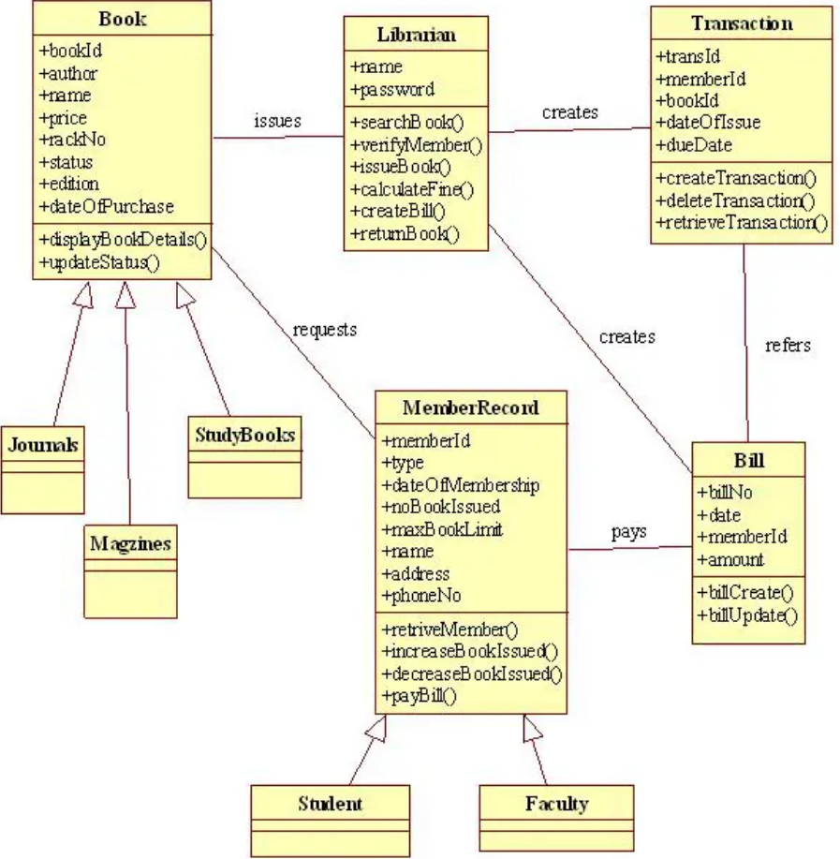

**Fig:4.1.1 Class Diagram**

* 1. **Sequence Diagram**

**Actor**: Represents the user or external system interacting with the DLS. In this case, the actor can be a "User" who wants to borrow a book or check their borrowed books.

**Objects**: Represent the key components or objects within the DLS. These objects can include "User," "Book," "Library," "Database," etc.

**Lifelines**: Depict the lifespan of an object during the interaction. Each object participating in the sequence diagram has a lifeline, represented as a vertical line beneath the object's name.

**Activation** **Boxes**: Show the period of time during which an object is actively processing a message. When an object is processing a message, an activation box is displayed on its lifeline.

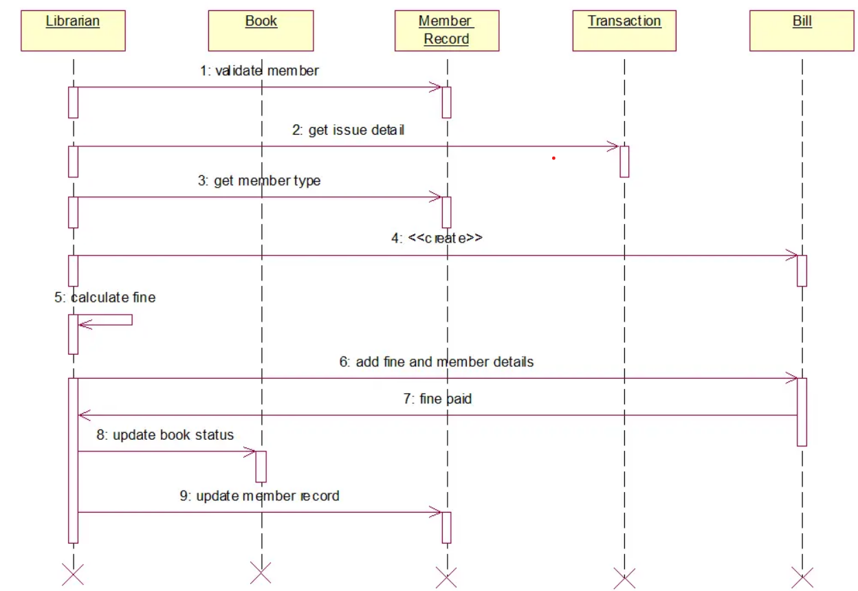

**Fig: 4.2.1 Sequence Diagram**

## USE CASE DAIGRAM

The use case diagram provides an overview of the system's functionality and the interactions between the users and the system. It helps to identify the different actions that users can perform and the roles of various actors in the system. This diagram serves as a communication tool between stakeholders, allowing them to understand the system's features and its alignment with user requirements.

**User**: Represents the primary actor in the system, which is the library user. The User interacts with the system to perform different actions.

**Admin**: Represents the secondary actor, which is the system administrator or librarian. The Admin has additional privileges and responsibilities compared to regular users.

### Requirements.

* + - U User Registration: The system should allow users to register for an account by providing necessary details such as name, email, and password.
    - User Login: Registered users should be able to log in to the system using their credentials.
    - Search Books: Users should be able to search for books based on various criteria such as title, author, or genre.
    - View Book Details: Users should be able to view detailed information about a selected book, including its title, author, description, and availability.
    - Borrow Book: Users should be able to borrow books from the library by selecting the desired book and completing the necessary borrowing process.
    - Return Book: Users should be able to return borrowed books to the library, updating their borrowing records accordingly.

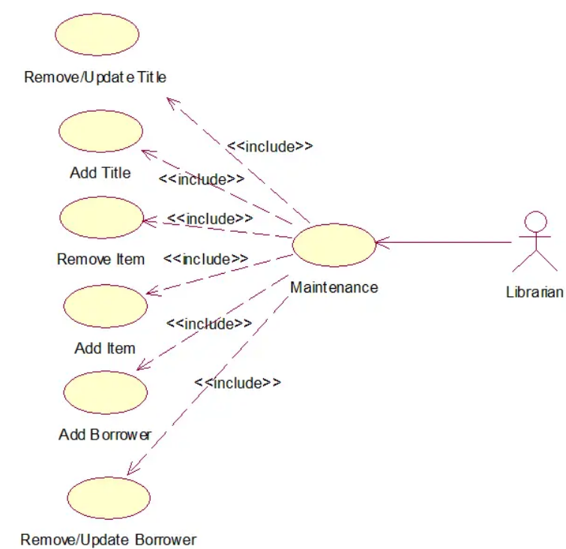

**Fig: 4.3.1 Use Case Diagram**

## Data Flow Diagram:

External Entities: These represent external entities that interact with the system. In the case of DLS, external entities can include users, administrators, and the library database.

Processes: Processes in the DFD represent the activities or transformations that occur within the system. In DLS, processes can include user registration, book search, book borrowing, book return, and report generation.

Data Flows: Data flows represent the movement of data between external entities, processes, and data stores. In DLS, data flows can include user information, book details, borrowing requests, return requests, and generated reports.

Data Stores: Data stores represent the storage or repositories of data within the system. In DLS, the data store can be the library database where information about users, books, and borrowing records are stored.

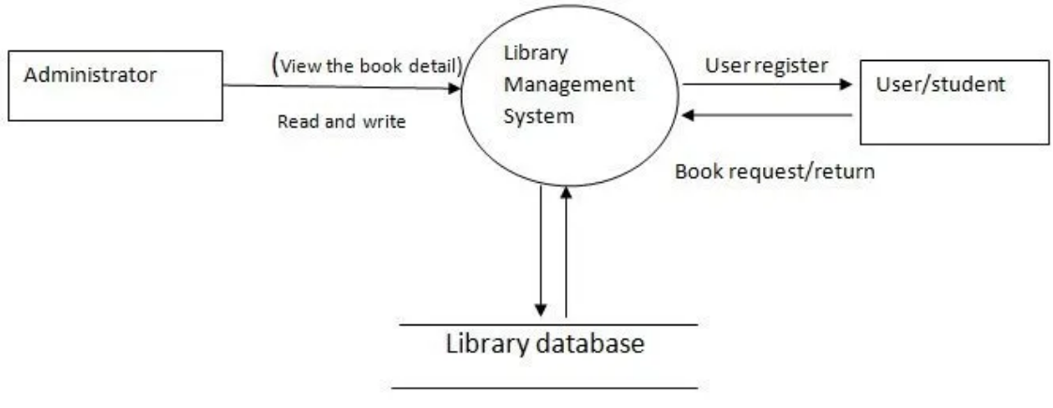

### Fig: 4.4.1 Data flow diagram

**Entity Relationship daigram**

Attributes in ER diagrams are usually modelled as an oval with the name of the attribute, linked to the entity or relationship that contains the attribute. Within the relational model the final step can generally be broken down into two further steps that of determining the grouping of information within the system, Generally determining what are the basic objects about which information is being stored, and then determining the relationships between these groups of information, or objects. This step is not necessary with an Object database.

* + - **Entity:** A data entity is anything real or abstract about which we want to store data.
    - **Relationship:** A data relationship is a natural association that exists between one or more entities. Cardinality defines the number of occurrences of one entity for a single occurrence of the related entity.
    - **Attribute:** A data attribute is a characteristic common to all or most instances of a particular entity. An attribute or combination of attributes that uniquely identifies one and only instance of an entity is called a primary key.
    - **Degree of Relationship:** Is the number of entities associated with the relationship.
    - **Connectivity and Cardinality**: The connectivity of relationship describes the mapping of associated entity instances in the relationship.
    - Entities: Entities represent the major objects or concepts within the system. In DLS, entities can include User, Book, Author, and Borrowing.
    - Relationships: Relationships define the associations between entities. In DLS, relationships can include "Borrowed by" between User and Book, "Written by" between Author and Book, and "Has" between User and Borrowing.
    - Attributes: Attributes are the properties or characteristics of entities. In DLS, attributes can include User ID, Name, Email, and Password for the User entity, Book ID, Title, Description, and Availability for the Book entity, and Author ID and Name for the Author entity.
    - Cardinality and Modality: Cardinality represents the number of instances of one entity that can be associated with another entity in a relationship. Modality represents whether the participation in a relationship is mandatory (denoted by a solid line) or optional (denoted by a dashed line). For example, a User can borrow multiple Books, and a Book can be borrowed by multiple Users, indicating a many-to-many relationship with a cardinality of "many" on both sides.

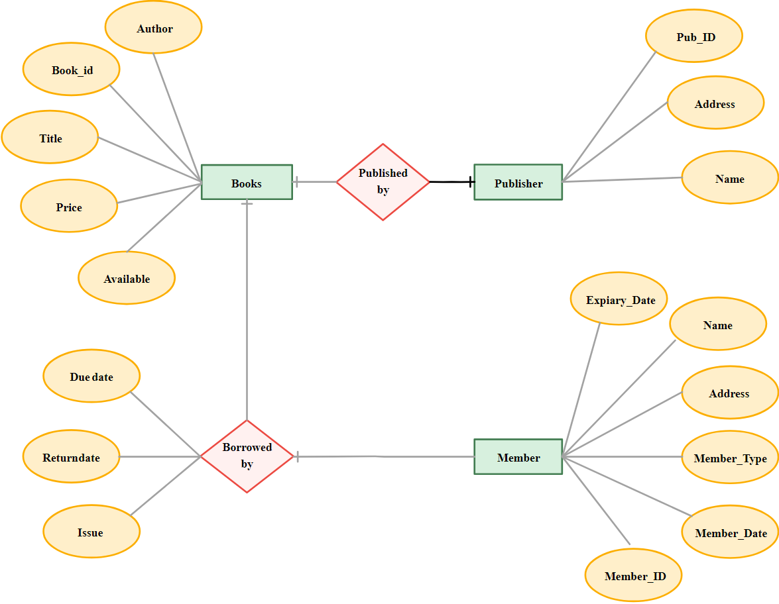

### Fig: 4.4.2 Entity Relationship Diagram

**Chapter 5**

# System Implementation

### System Architecture

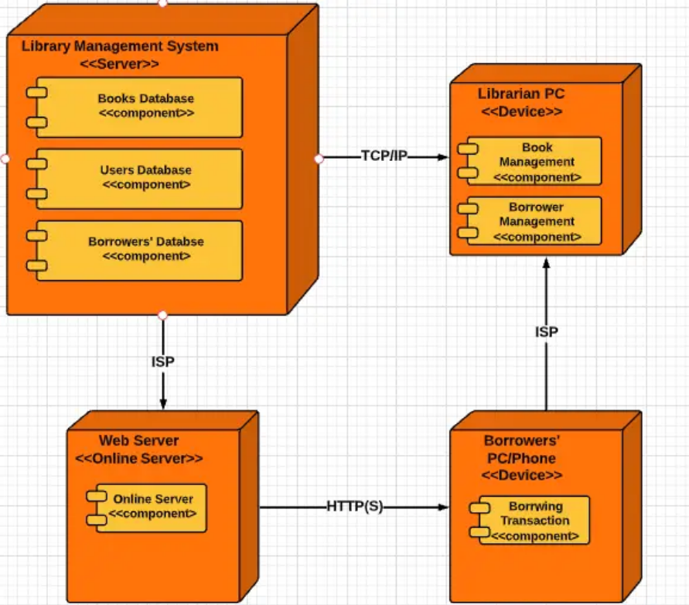

**Fig:5.1.1: System Architecture**

* 1. **SCREEN SHOTS OF THE PROJECT:**

### Home page

### 

Fig:5.2.1: Home Page

**Login Page**

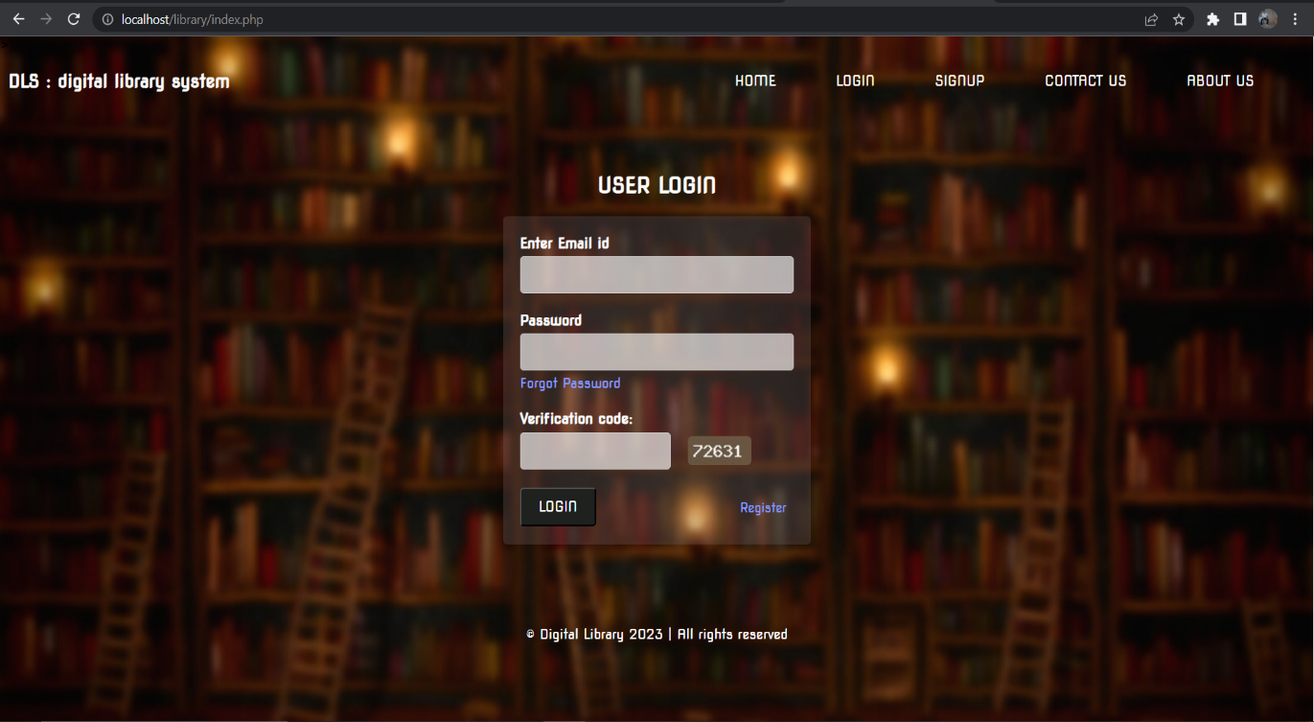

Fig:5.2.2: User Login

### Sign Up Page

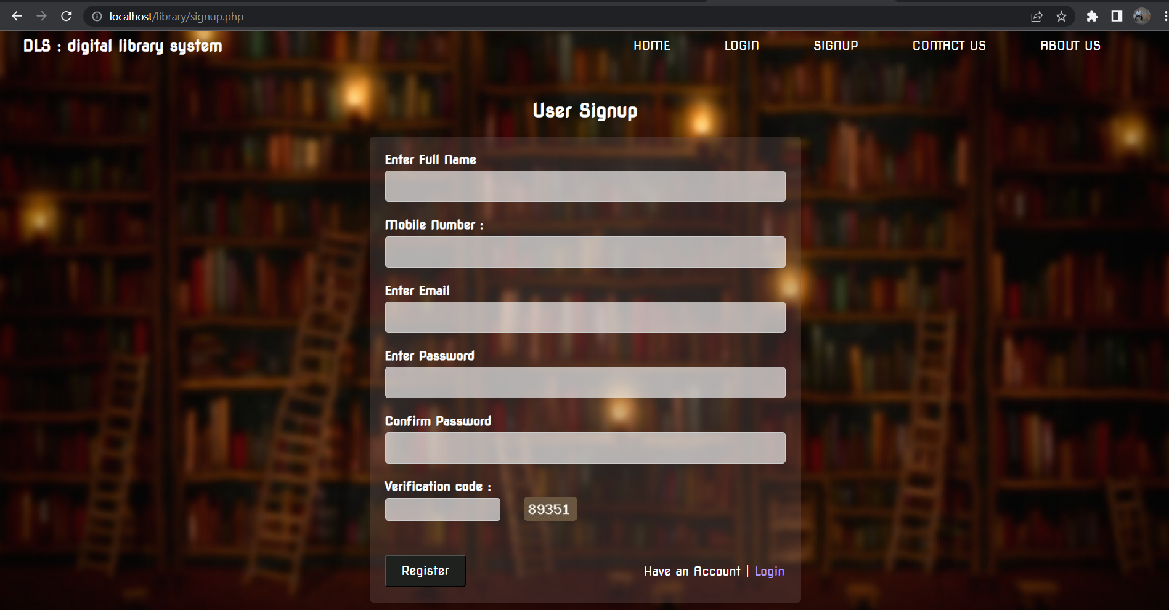

Fig:5.2.3: User Sign Up

**User Dashboard**

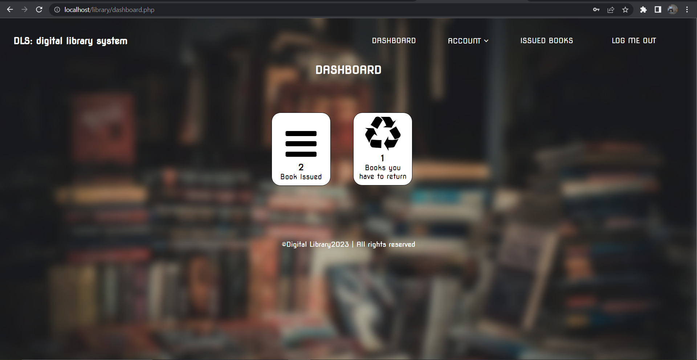

Fig:5.2.4: User Dashboard

### Borrowed Books Data

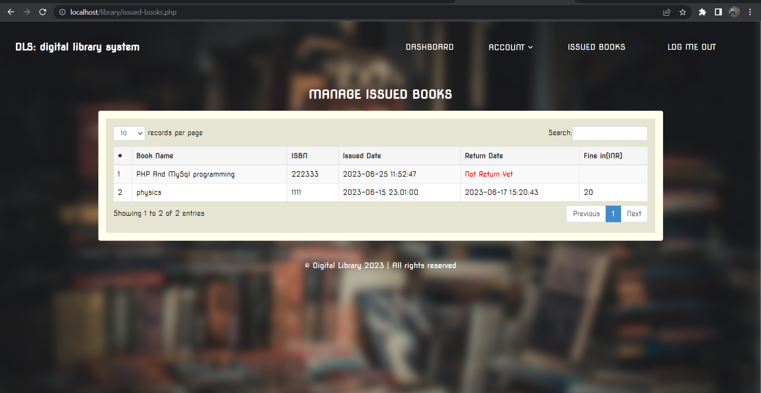

Fig:5.2.5: Borrowed Books Data

**User Profile**

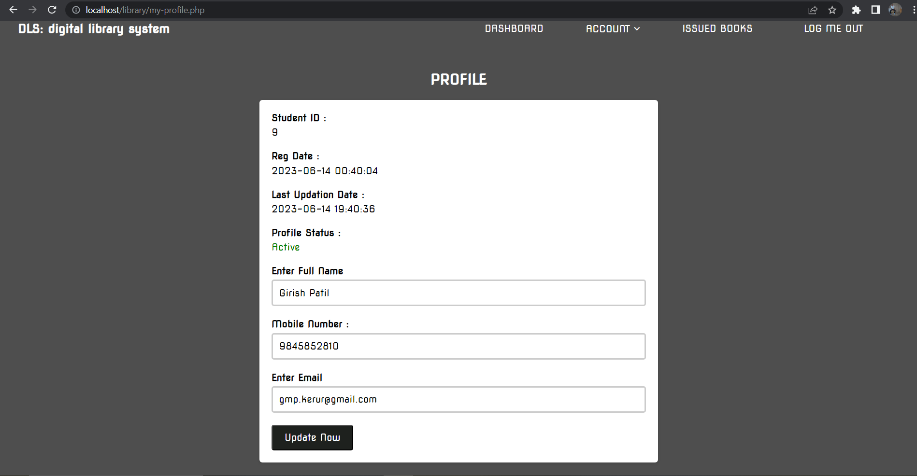

Fig:5.2.6: User Profile

**Admin Login**

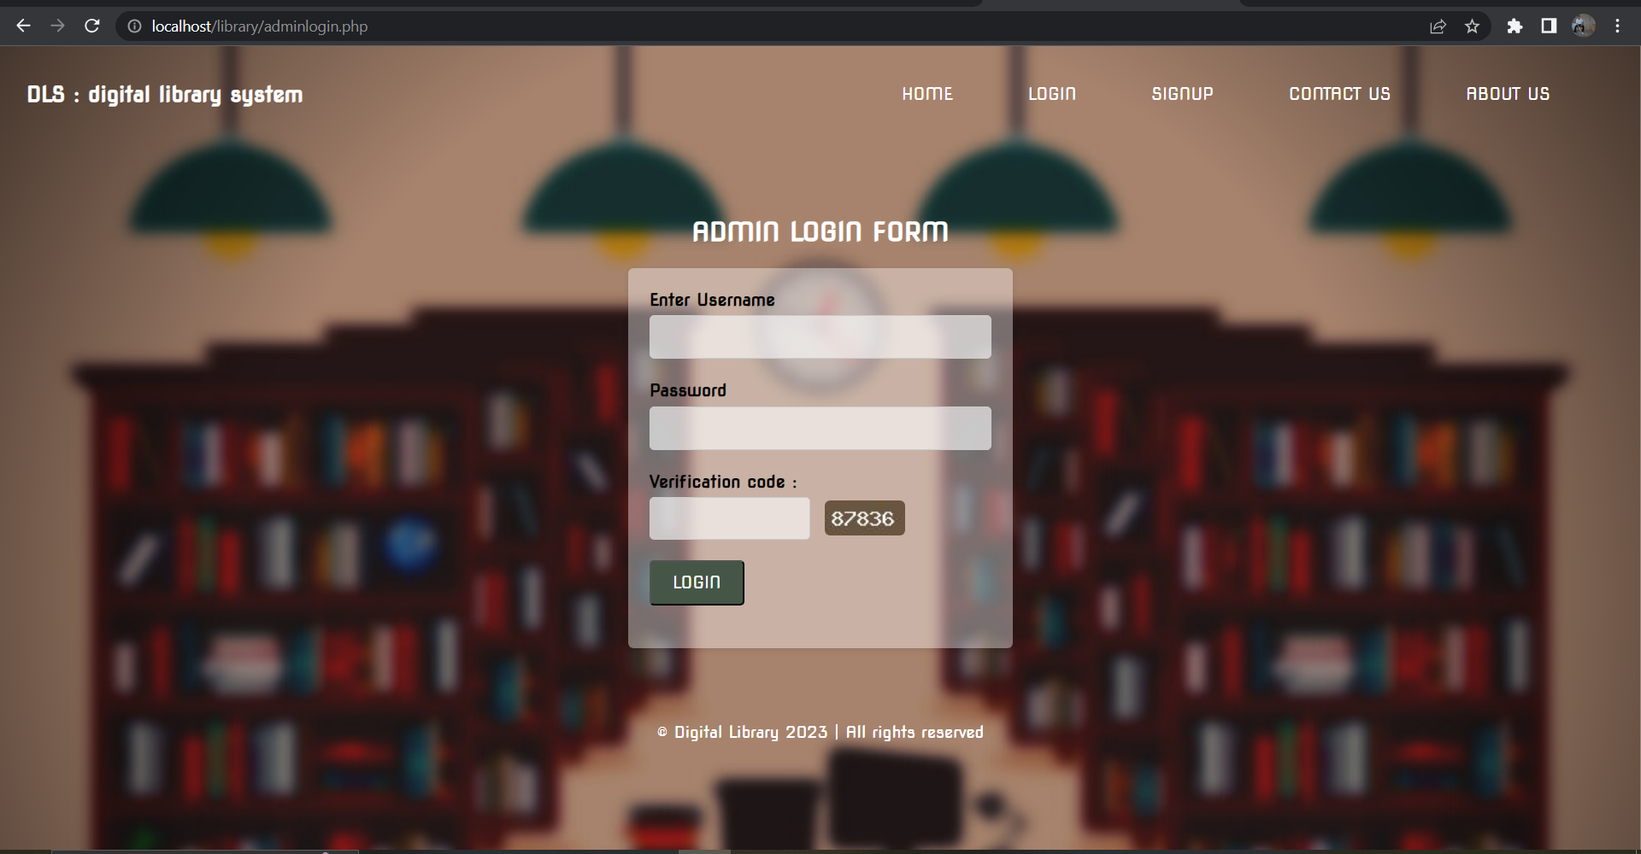

Fig:5.2.7: Admin Login

**Admin Dashboard**

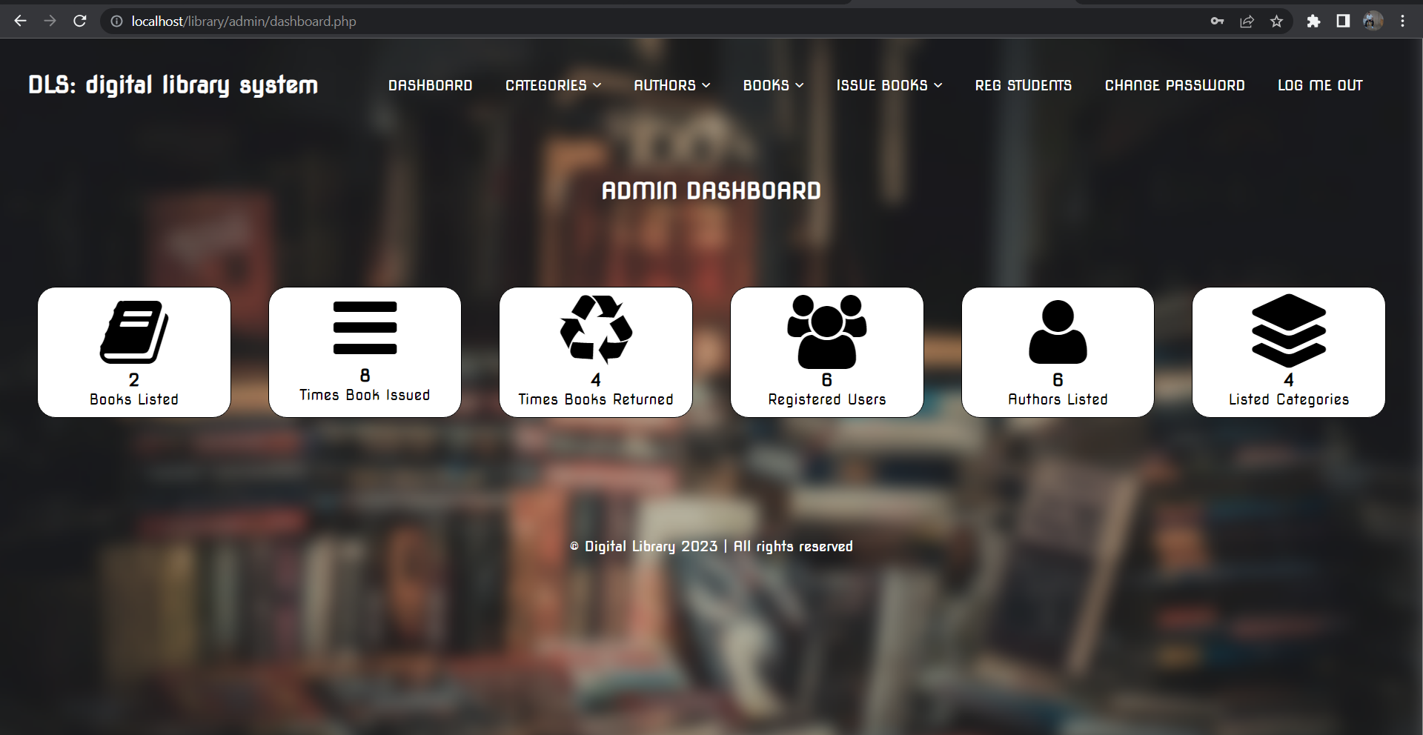

Fig:5.2.8: Admin Dashboard

**Registered Students**

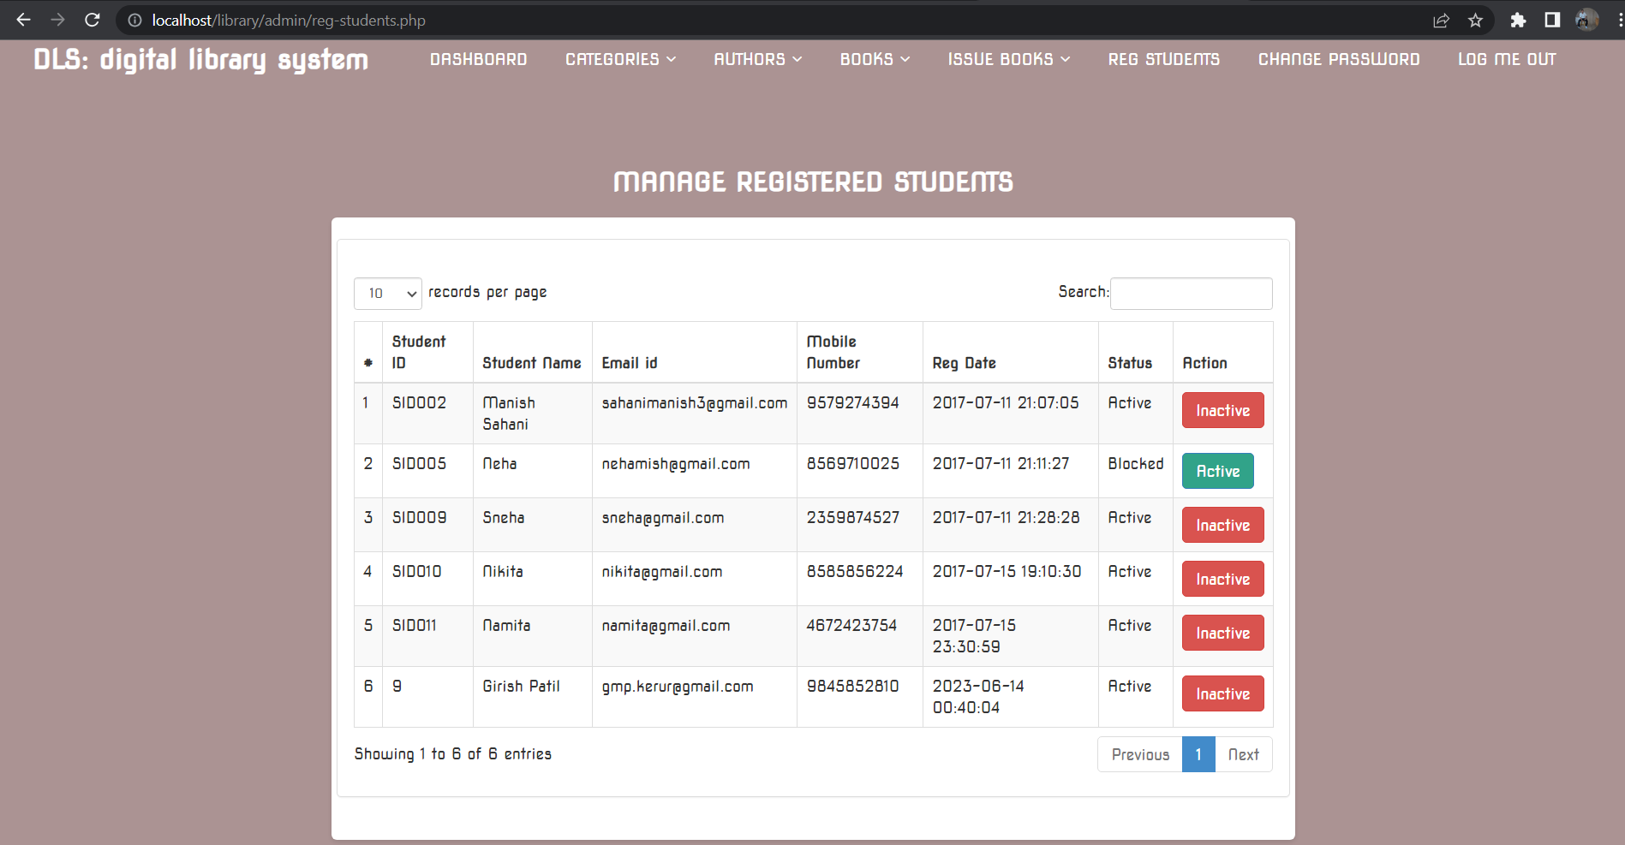

Fig:5.2.9: Registered Students

**Database Page**

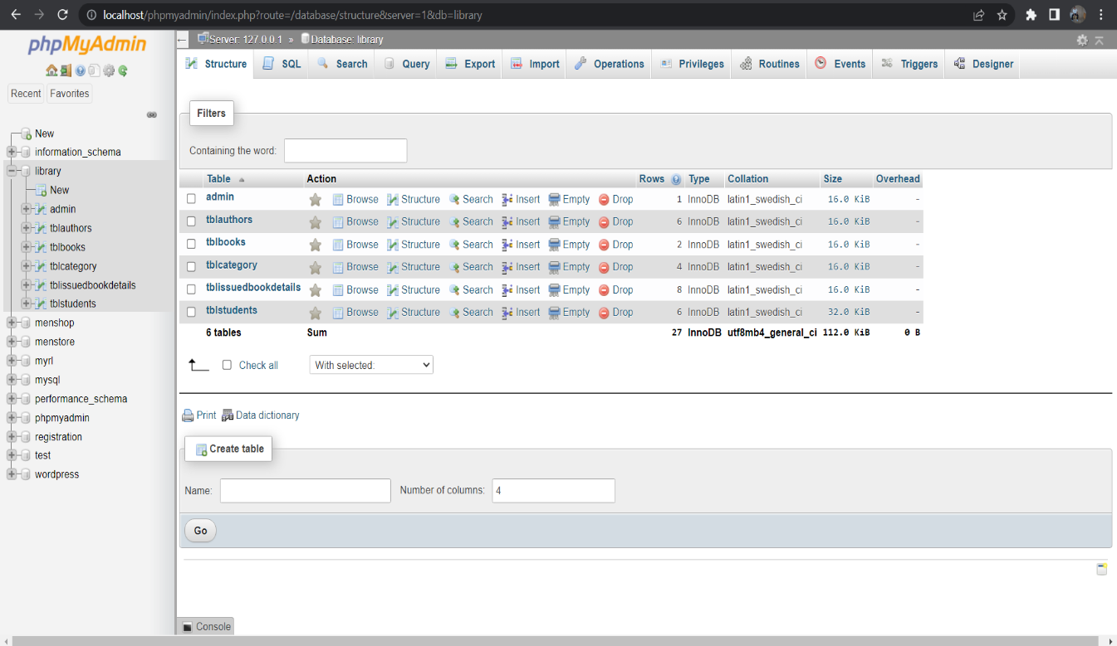

Fig:5.2.10: Database & Tables

**Table Authors**

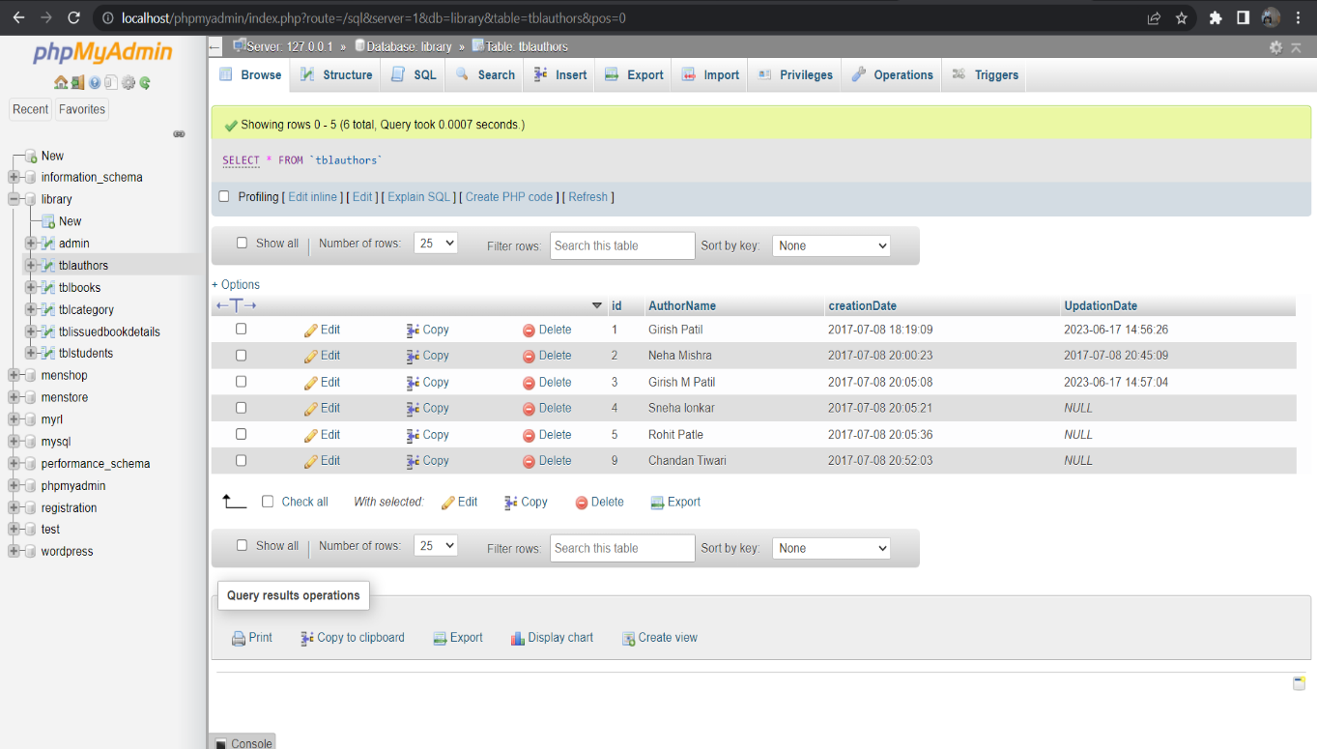

Fig:5.2.11: Authors Table

**Table Registered Students**

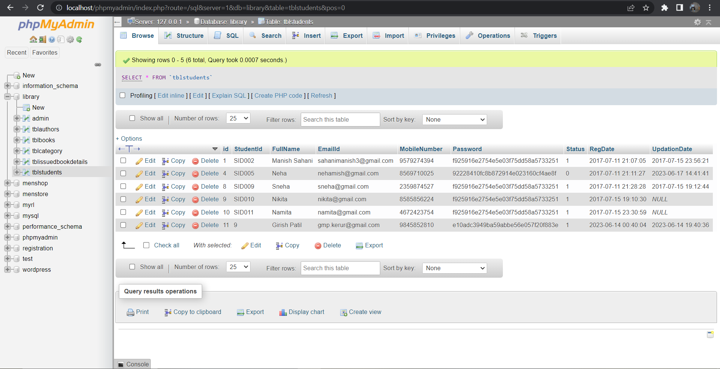

Fig:5.2.12: Registered Student Table

**Table Issued Books**

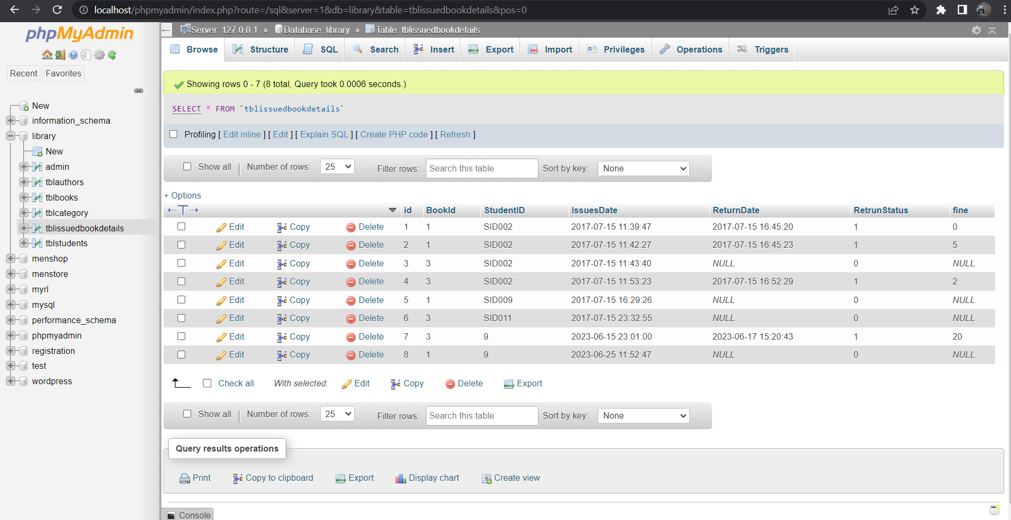

Fig:5.2.13: Issued Books Table

## Chapter 6

**Sample code**

**Home.php**

<!DOCTYPE html>

<html lang="en">

<head>

<meta charset="UTF-8">

<meta name="viewport" content="width=device-width, initial-scale=1.0">

<title>Digital Library System</title>

<link rel="stylesheet" href="assets/css/home.css">

<link rel="icon" type="image/png" href="assets/img/icon.png">

<link href='https://fonts.googleapis.com/css?family=Nova Square' rel='stylesheet'>

<script src="https://kit.fontawesome.com/2f4be6bad1.js" crossorigin="anonymous"></script>

</head>

</head>

<body>

<header class="hero-section">

<div class="hero-content">

<a href="contactus.php" class="contact-icon"><i class="fa-sharp fa-solid fa-phone-volume"></i></a>

<span class="contact">contact</span>

<a href="aboutus.php" class="about-icon"><i class="fa-solid fa-address-card "></i></a>

<span class="about">about</span>

<a href="adminlogin.php" class="admin-icon"><i class="fa-solid fa-user-tie "></i></a>

<span class="admin">admin</span>

<h1>Welcome to DLS</h1>

<p>Effortless book management for library</p>

<a href="signup.php" class="cta-button">Get Started</a>

<div style="margin-top: 3px;"><a href="index.php" class="login-button">LOGIN</a></div>

</div>

</header>

<section class="features-section">

<div class="feature">

<i class="fa-solid fa-book fa-2x"></i>

<h2>Manage Books</h2>

<p>Add, update, and organize books in your library</p>

</div>

<div class="feature">

<i class="fas fa-search fa-2x"></i>

<h2>Quick Search</h2>

<p>Efficiently find books using advanced search capabilities</p>

</div>

<div class="feature">

<i class="fas fa-user fa-2x"></i>

<h2>User Accounts</h2>

<p>Create and manage user accounts for library members</p>

</div>

</section>

<section class="latest-updates-section">

<h2>Latest Updates</h2>

<div class="latest-updates-container">

<div class="latest-updates-container">

<div class="latest-update">

<h3>New Feature: Online Book Reservations</h3>

<p>We are excited to announce the launch of our new online book reservation system. Now, library members can easily reserve books through our website or mobile app.</p>

</div>

<div class="latest-update">

<h3>Library Closure Notice</h3>

<p>Please note that the library will be closed for maintenance from June 20th to June 25th. We apologize for any inconvenience caused.</p>

</div>

</div>

</section>

<section class="new-arrivals-section">

<h2>New Arrivals</h2>

<div class="new-arrivals-container">

<div class="new-arrival">

<h3>Big Data For Beginners</h3>

<p>by Vince Reynolds</p>

</div>

<div class="new-arrival">

<h3>Introduction to Machine Learning with Python</h3>

<p>by Andreas C. Müller, Sarah Guido</p>

</div>

</div>

</section>

<?php include('includes/footer.php'); ?>

</body>

</html>

**Home.css**

* {

font-family: "Nova Square", sans-serif;

box-sizing: border-box;

margin: 0;

padding: 0;

}

/* Hero section styles */

.hero-section {

background-image: url('../img/hero.png');

background-size: cover;

background-position: center;

height: 550px;

display: flex;

align-items: center;

justify-content: center;

text-align: center;

color: #fff;

}

.hero-content {

max-width: 800px;

margin: 0 auto;

}

.admin-icon {

position: absolute;

top: 15px;

right: 23px;

color: #fff;

font-size: 30px;

text-decoration: none;

}

.about-icon {

position: absolute;

top: 15px;

right: 100px;

color: #fff;

font-size: 30px;

text-decoration: none;

}

.contact-icon {

position: absolute;

top: 15px;

right: 185px;

color: #fff;

font-size: 30px;

text-decoration: none;

}

.admin {

position: absolute;

top: 50px;

right: 15px;

color: #fff;

font-size: 15px;

text-decoration: none;

}

.about {

position: absolute;

top: 50px;

right: 97px;

color: #fff;

font-size: 15px;

text-decoration: none;

}

.contact {

position: absolute;

top: 50px;

right: 172px;

color: #fff;

font-size: 15px;

text-decoration: none;

}

h1 {

font-size: 36px;

margin-bottom: 20px;

color: #fff;

}

p {

font-size: 20px;

margin-bottom: 30px;

color: #fff;

}

.cta-button {

display: inline-block;

padding: 8px;

background-color: #fff;

color: #333;

text-decoration: none;

font-weight: bold;

border-radius: 5px;

transition: background-color 0.3s ease;

}

.cta-button:hover {

background-color: #8562629c;

}

.login-button {

display: inline-block;

padding: 5px;

background-color: #fff;

color: #333;

text-decoration: none;

font-weight: bold;

border-radius: 5px;

transition: background-color 0.3s ease;

}

.login-button:hover {

background-color: #8562629c;

}

/* Features section styles */

.features-section {

background-color: #beb8b86e;

padding: 50px 0;

display: flex;

justify-content: center;

}

.feature {

text-align: center;

max-width: 300px;

margin: 0 20px;

}

.feature img {

width: 100px;

margin-bottom: 20px;

}

.feature h2 {

font-size: 24px;

margin-bottom: 10px;

color: #333;

}

.feature p {

font-size: 16px;

color: #333;

}

/* new arrival and telest updates*/

.latest-updates-section {

padding: 50px 0;

background-color: #c1c1c1de;

}

.latest-updates-section h2 {

text-align: center;

font-size: 24px;

margin-bottom: 20px;

}

.latest-updates-container {

display: flex;

justify-content: center;

}

.latest-update {

text-align: center;

max-width: 300px;

margin: 0 20px;

}

.latest-update h3 {

font-size: 20px;

margin-bottom: 10px;

color: #333;

}

.latest-update p {

font-size: 16px;

color: #333;

}

.new-arrivals-section {

padding: 50px 0;

background-color: #b3afacde;

}

.new-arrivals-section h2 {

text-align: center;

font-size: 24px;

margin-bottom: 20px;

}

.new-arrivals-container {

display: flex;

justify-content: center;

}

.new-arrival {

text-align: center;

max-width: 300px;

margin: 0 20px;

}

.new-arrival h3 {

font-size: 20px;

margin-bottom: 10px;

color: #333;

}

.new-arrival p {

font-size: 16px;

color: #333;

}

/* Footer styles */

.footer-section {

padding: 7px;

color: #000;

font-size: 15px;

text-align: center;

background-color: #a49f9f;

}

.footer-section a {

text-decoration: none;

color: #000;

}

.footer-section a:hover {

color: #ffffffed;

}

.social-icons a {

margin-left: 10px;

}

.social-icons img {

width: 20px;

}

## Chapter 7

**Introduction:**

# System Testing

Software testing is a critical element of software quality assurance and represents the ultimate review of specification, design and coding. In fact, testing is the one step in the software engineering process that could be viewed as destructive rather than constructive.

A strategy for software testing integrates software test case design methods into a well- planned series of steps that result in the successful construction of software. Testing is the set of activities that can be planned in advance and conducted systematically. The underlying motivation of program testing is to affirm software quality with methods that can economically and effectively apply to both strategic to both large and small-scale systems.

### STRATEGIC APPROACH TO SOFTWARE TESTING

The software engineering process can be viewed as a spiral. Initially system engineering defines the role of software and leads to software requirement analysis where the information domain, functions, behavior, performance, constraints and validation criteria for software are established. Moving inward along the spiral, we come to design and finally to coding. To develop computer software we spiral in along streamlines that decrease the level of abstraction on each turn.

A strategy for software testing may also be viewed in the context of the spiral. Unit testing begins at the vertex of the spiral and concentrates on each unit of the software as implemented in source code. Testing progress by moving outward along the spiral to integration testing, where the focus is on the design and the construction of the software architecture. Talking another turn on outward on the spiral we encounter validation testing where requirements established as part of software requirements analysis are validated against the software that has been constructed. Finally we arrive at system testing, where the software and other system elements are tested as a whole.

DIGITAL LIBRARY SYSTEM

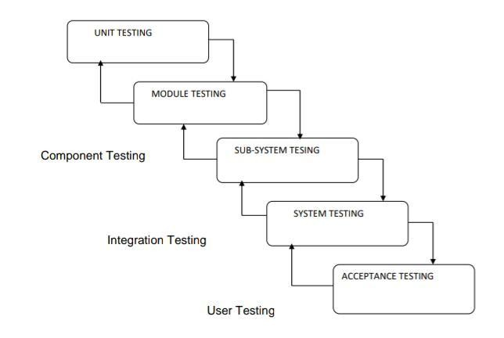

### UNIT TESTING

Unit testing focuses verification effort on the smallest unit of software design, the module. The unit testing we have is white box oriented and some modules the steps are conducted in parallel.

### WHITE BOX TESTING

This type of testing ensures that

* All independent paths have been exercised at least once
* All logical decisions have been exercised on their true and false sides
* All loops are executed at their boundaries and within their operational bounds
* All internal data structures have been exercised to assure their validity.

To follow the concept of white box testing we have tested each form. we have created independently to verify that Data flow is correct, All conditions are exercised to check their validity, All loops are executed on their boundaries.

### BASIC PATH TESTING

Established technique of flow graph with Cyclamate complexity was used to derive test cases for all the functions. The main steps in deriving test cases were:

Use the design of the code and draw correspondent flow graph.

Determine the Cyclamate complexity of resultant flow graph, using formula: V(G)=E-N+2 or V(G)=P+1 or

V (G) =Number Of Regions

Where V (G) is Cyclomatic complexity, E is the number of edges,

N is the number of flow graph nodes, P is the number of predicate no

### CONDITIONAL TESTING

In this part of the testing each of the conditions were tested to both true and false aspects. And all the resulting paths were tested. So that each path that may be generate on particular condition is traced to uncover any possible errors.

#### DATA FLOW TESTING

This type of testing selects the path of the program according to the location of definition and use of variables. This kind of testing was used only when some local variable were declared. The *definition-use chain* method was used in this type of testing. These were particularly useful in nested statements.

#### LOOP TESTING

In this type of testing all the loops are tested to all the limits possible. The following exercise was adopted for all loops:

* + All the loops were tested at their limits, just above them and just below them.
  + All the loops were skipped at least once.
  + For nested loops test the inner most loop first and then work outwards.
  + For concatenated loops the values of dependent loops were set with the help of connected loop.
  + **Test Cases and Result:**

|  |  |  |  |
| --- | --- | --- | --- |
| **MODULE** | **TEST CASE** | **EXPECTED RESULT** | **OBSERVED RESULT** |
| DLS | New candidate tries to login | Username does not exist | PASS |
| DLS | Provides wrong password | Username/password does not exist | PASS |
| DLS | Provides invalid username | Username/password does not exist | PASS |
| DLS | Registers to the portal | Registration Successful | PASS |
| DLS | Registers with existing credential | User /email already exists | PASS |
| DLS | Click login | User Homepage  with all books he borrowed and returned | PASS |

**Chapter 8**

# Conclusion

the Digital Library System (DLS) is a comprehensive solution that aims to automate and streamline library management processes. The system provides a user-friendly interface for both library staff and members, enabling efficient book management, user account management, and borrowing operations. By leveraging technology and automation, DLS eliminates manual paperwork, reduces administrative overhead, and enhances the overall user experience.

Throughout the development of the DLS, various aspects were considered, such as the functional requirements, usability, security, and performance. The system offers features like book search, reservation, due date tracking, and notifications to ensure a seamless borrowing experience for library members. It also facilitates efficient book inventory management, enabling library staff to track available books, monitor borrowing patterns, and generate reports for informed decision-making.

The implementation of the DLS brings numerous benefits to both the library and its members. Library staff can streamline their operations, improve resource utilization, and deliver enhanced services to library members. Users, on the other hand, can conveniently browse the book collection, check availability, and manage their borrowed items. By offering a digital platform, the DLS extends the reach of the library beyond physical boundaries, allowing users to access library services anytime, anywhere.

In conclusion, the Digital Library System is a valuable tool for modern libraries, providing automation, efficiency, and convenience in managing library resources and serving library members. The system empowers libraries to adapt to the digital era and deliver an enhanced user experience, fostering a culture of learning and knowledge sharing.

# Bibliography

### Books

* + Conallen, J. (2003). Building Web Applications with UML. Pearson Education, Inc.
  + Firth, R. (2005). High Powered CVs. How to Books Publishing.
  + Maier, M. & Rechtin, E. (2000). The Art of Systems Architecting 2nd Edition. CRC Press.
  + Schmuller, J. (2004). Sams Teach Yourself UML in 24 Hours, Third Edition. Sams Publishing.

### Articles/Journals

* + Smith, J. (2022). Digital Libraries: Management and Implementation. Publisher.
  + And here's an example of how a journal article citation might look in MLA style:
  + Doe, J. "Advancements in Library Management Systems." Journal of Library Technology, vol. 10, no. 2, 2021, pp. 45-60.

### Web Sites

* https://koha-community.org/
* https://evergreen-ils.org/
* https://www.exlibrisgroup.com/products/alma-library-services-platform/
* https://www.sirsidynix.com/products/symphony/
* https://www.oclc.org/en/worldshare-management-services.html
* https://librarika.com/
* https://www.biblionix.com/apollo/